Title: Sample Module doc v 0.7 (*Title* style)

# What?

This web page and [the Word document](https://griffitheduau-my.sharepoint.com/:w:/g/personal/d_jones6_griffith_edu_au/EUbAQvhxLW1MicRKf9Hof3sBIoS2EyJP_SfkYbqZ7c3qhw?e=2S9k3Y) from which it is produced is an example of a new process (currently called the **Content Interface**) designed to make it easier to create and maintain learning modules hosted in Learning@Griffith (Blackboard 9.1).

You are viewing either the Word version of the module (here’s [an online version of the Word document](https://griffitheduau-my.sharepoint.com/:w:/g/personal/d_jones6_griffith_edu_au/EUbAQvhxLW1MicRKf9Hof3sBIoS2EyJP_SfkYbqZ7c3qhw?e=2S9k3Y)) or you are viewing the online version of the module ([via Learning@Griffith](https://bblearn.griffith.edu.au/webapps/blackboard/content/listContent.jsp?course_id=_73051_1&content_id=_4411002_1&mode=reset), Blackboard 9.1).

**No access to online versions?**

To access both the online Word document and the Blackboard page you need to:

1. Be a Griffith Staff member; and  
2. Been granted access.

If you’d like to be granted access, please [contact David Jones](mailto:https://app.griffith.edu.au/phonebook/phone-details.php?id=1703323&string=david+jonesmailto:d.jones6@griffith.edu.au).

### Latest updates

|  |  |
| --- | --- |
| Date | Update |
| Aug-2020 | Added *University Date* style to enable automatic generation of dates. |
| Jul-2020 | Initial support for footnotes as tooltips – see the Footnotes section in the *How to add/edit normal Word content* section. |
| 14-Nov-2019 | Added support to change which Level 1 accordions are open by default. |
| 6-Nov-2019 | Added support to embed links directly to Blackboard Content and Course Menu items. |

# Why?

Because Blackboard 9.1 makes it hard to create and maintain good quality online learning content with a contemporary and responsive interface. [This thread](https://community.blackboard.com/thread/6523-content-editor-html-vs-pdf) on the Blackboard community site shares some of the challenges, and [this blog post](http://abelardopardo.blogspot.com/2015/02/re-visiting-authoring-reauthoring.html) shows that it’s not just Blackboard.

By lowering the barrier and providing explicit support for creating and maintaining online learning content, it is hoped that the content interface will:

1. Reduce the workload for all involved.
2. Lift the quality of what can be produced.
3. Improve both the learning and teaching experience.
4. Perhaps, eventually, improve learning outcomes.

By starting with Word documents, the process harnesses existing widespread academic familiarity with Word and associated tools (e.g. citation management with EndNote). It inserts the ability to automatically transform and uplift that Word content into a quality online format. That transformation is flexible and we’ve only touched the surface of what could be done.

**Early days**

This process is still in its infancy. There is much more that could be done. There will be some bugs, foibles, and limitations. You can report issues, make suggestions, and see current known issues on [this page](https://github.com/djplaner/Content-Interface-Tweak/issues).

Please do give feedback, make suggestions and share frustrations [with David Jones](mailto:d.jones6@griffith.edu.au).

# Overview of the rest of this document

The following table explains the rest of this document and how you might use it.

|  |  |  |
| --- | --- | --- |
| **Section** | **Purpose** | **How to use it** |
| How do you use it? | Step-by-step description of the process used to create content in Blackboard using the content interface | Use this Word document and your own Blackboard content area to follow the steps |
| How do you include images, video…? | How to structure a Word document to produce output like this and include common content | Compare and contrast the Word and Blackboard versions of this document. |
| How do you integrate Blackboard items? | How to integrate Blackboard items (e.g. discussion board, quiz etc.) | Take the quiz, view the discussion board and look at the Word document |
| How do you **link** to Blackboard items? | How to embed links to Blackboard menu and course items | Take the quiz and jump to the presentation. |
| How do you link to a specific top-level section? | How link directly to an accordion. | Compare and contrast the Word and Blackboard versions. |
| How do you customise the accordion interface? | How to change the styling (colour, fonts etc) of the accordion interface. | Follow the process to customise your own content area. |

# How do you use it?

The following provides an overview of the 5-step process you can use to create and maintain content in Blackboard using this approach.

### Play along at home

If you have access to a Blackboard 9.1 content area, please feel free to use this Word document to create your first content interface page. Meaning you could skip Step 1 below and go straight to Step 2.

### Compare the Word and Blackboard versions of the module

1. Once you have been given access (see note on previous page), open up the [Word document](https://griffitheduau-my.sharepoint.com/:w:/g/personal/d_jones6_griffith_edu_au/EUbAQvhxLW1MicRKf9Hof3sBIoS2EyJP_SfkYbqZ7c3qhw?download=1) and [Blackboard versions](https://bblearn.griffith.edu.au/webapps/blackboard/content/listContent.jsp?course_id=_73051_1&content_id=_4411002_1&mode=reset) of the module.

2. Compare the content and interface of the two versions, what similarities and differences do you see?

## 1. Create content in Word using styles

The first step is to create some content in a Word document. The Word document should use both normal Word styles (e.g. *Heading 1*, *Heading 2*, *Quotations* etc.) and some content interface specific styles (e.g. *Embed*, *Activity*, *Reading*, etc.) to structure the content of a Word document. (The following paragraph has been styled with the *Activity* style)

**Find out more about Word styles**

If you’re unfamiliar with using styles in Word documents, please refer to the plethora of online resources (e.g. [this one](https://shaunakelly.com/word/styles/tipsonstyles.html)). A quick search for *introduction word styles* should find most.

## 2. Set up the Blackboard content area (first time only)

In order to fully transform the authored content, the content interface requires that the Blackboard content area (see

Figure 1) be set up in a specific way. This set up only needs to be done the first time a specific Blackboard content area is used.

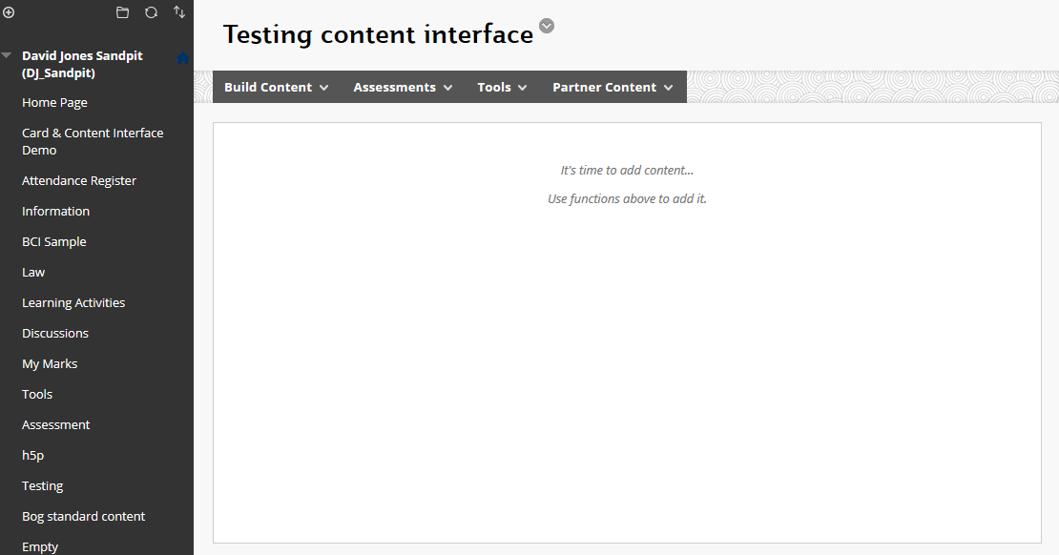

Figure 1 - Empty content area in Blackboard

For the content interface to work with a Blackboard content area like

Figure 1. It is necessary to add two content items to the area:

1. Content Interface; and,  
   An empty content item with the name **Content Interface** should be created first. It is empty because this is where the content from the Word document will be placed.
2. Tweak code.  
   A second content item needs to be created (it can be called what you would like – it will be invisible to students). This item should contain [the HTML code available here](https://raw.githubusercontent.com/djplaner/Content-Interface-Tweak/master/tweak.html). This tweak code will transform the original content. [These instructions](http://www.bu.edu/tech/services/teaching/lms/blackboard/how-to/copypaste-into-blackboard-learn/) offer some advice on how to copy and paste the tweak code using the HTML Code View.

Figure 2 shows what you should see after completing the above two steps.

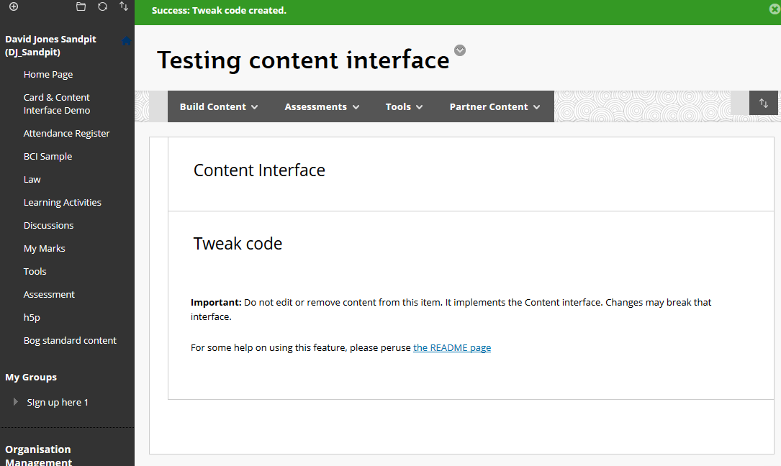

Figure 2 - Content area prepared for the content interface

## 3. Convert Word to HTML

The next step is convert your Word document to HTML that is ready to pasted into your Blackboard content area. To do this, you should:

1. Visit [this page](https://djon.es/gu/mammoth.js/browser-demo/);  
   This is the service that will convert your Word document to HTML.
2. Use the **Choose File** button to select your Word document.  
   Use the dialogue box to find and select your Word document.  
     
   **Note:** You may need to close your Word document before you start this step.
3. Check the HTML;  
   Almost immediately, the content from your Word document should appear on the page (see Figure 3). Check through the displayed HTML to check for any problems in the conversion process.
4. Check the messages;  
   Scroll to the bottom of the page and check for any warnings or errors in the **Messages** section. Figure 4 shows a message about an unrecognised style. Most messages – such as this one- mean that a particular Word style was not recognised by the conversion process. Typically the content will still appear in the document.
5. Use the **Click to copy** button.  
   This button copies the HTML code used to display your content on the Web. Ready for you to paste it into Blackboard.

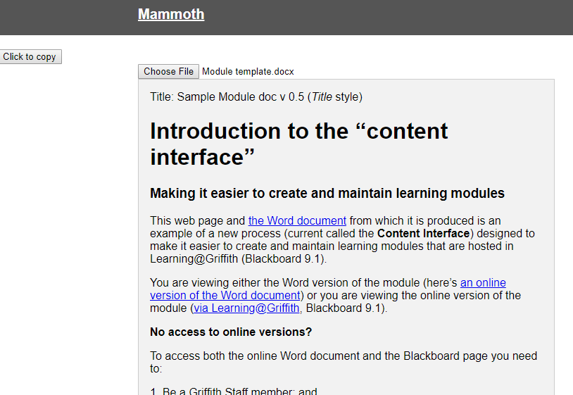

Figure 3 - HTML produced, time to check

**Changing styles that are recognised**

Currently, this conversion process is configured to convert the styles listed in this document. These styles can be modified and added to in order to support different types of documents.

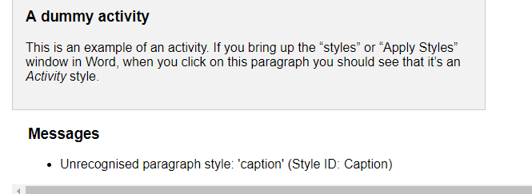

Figure 4 - Checking messages

## 4. Paste HTML into Blackboard

Having converted a Word document into HTML, it’s time to paste the content into Blackboard. To do this, you would:

1. Go to the Blackboard content area you prepared previously (see Figure 2);
2. Edit the **Content Interface** item.  
   [This document](https://help.blackboard.com/Learn/Instructor/Course_Content/Create_Content/Edit_and_Manage_Content) explains how to edit a Blackboard item.
3. Paste the HTML code into this item.  
   Using the same [instructions](http://www.bu.edu/tech/services/teaching/lms/blackboard/how-to/copypaste-into-blackboard-learn/) from above for how to paste using the HTML Code View.
4. Update and Submit the changes.

If all has worked, you will be left with a Blackboard page that now contains the content from your Word document. For example, Figure 5 showing the transformed HTML also shown in Figure 3 (and taken from this Word document).

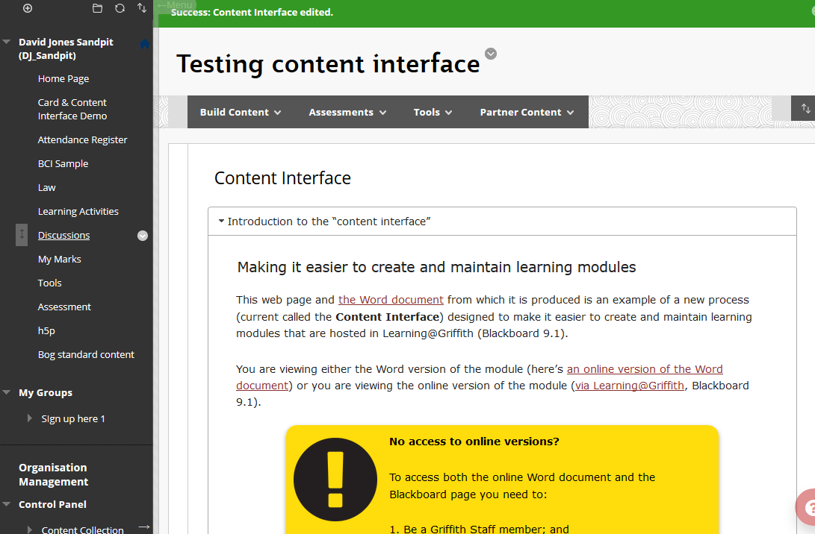

Figure 5 - Working content interface

## 5. Go to Step 1 to make changes to your Word document

You should never use Blackboard to edit the content. Instead, the original Word document should be used to make changes by returning to step 1 (remembering that Step 2 should only be done the first time)

# How do you update Blackboard content with the Content Interface

The following explains one process for using the Content Interface to change content in Blackboard. The sections that following, include:

* This works if you can…;  
  Defines what you need to see in Blackboard for this process to work for you.
* Edit the Word document;  
  The first step is you make all your changes in the Word document.
* Convert to HTML;  
  Next, that Word document has to be converted to HTML – the language used to generate Web pages.
* Paste into Blackboard; and,
* View the changes

## This works if you can…

The update process shown in this section works if, when Editing is turned on, the Blackboard page you want to edit contains the three items shown in the image below.

The three items are:

1. Content Interface;  
   This is where the content you are editing will be displayed. You will paste the new content into this.
2. Content Management Instructions; and,  
   These are the instructions and *Update Content Interface* functionality you will use to update the content.
3. Content Document.  
   This is a link to the Word document you will edit to make the change. You will also need to have permission to edit the Word document.

The order of these items in Blackboard does NOT matter.

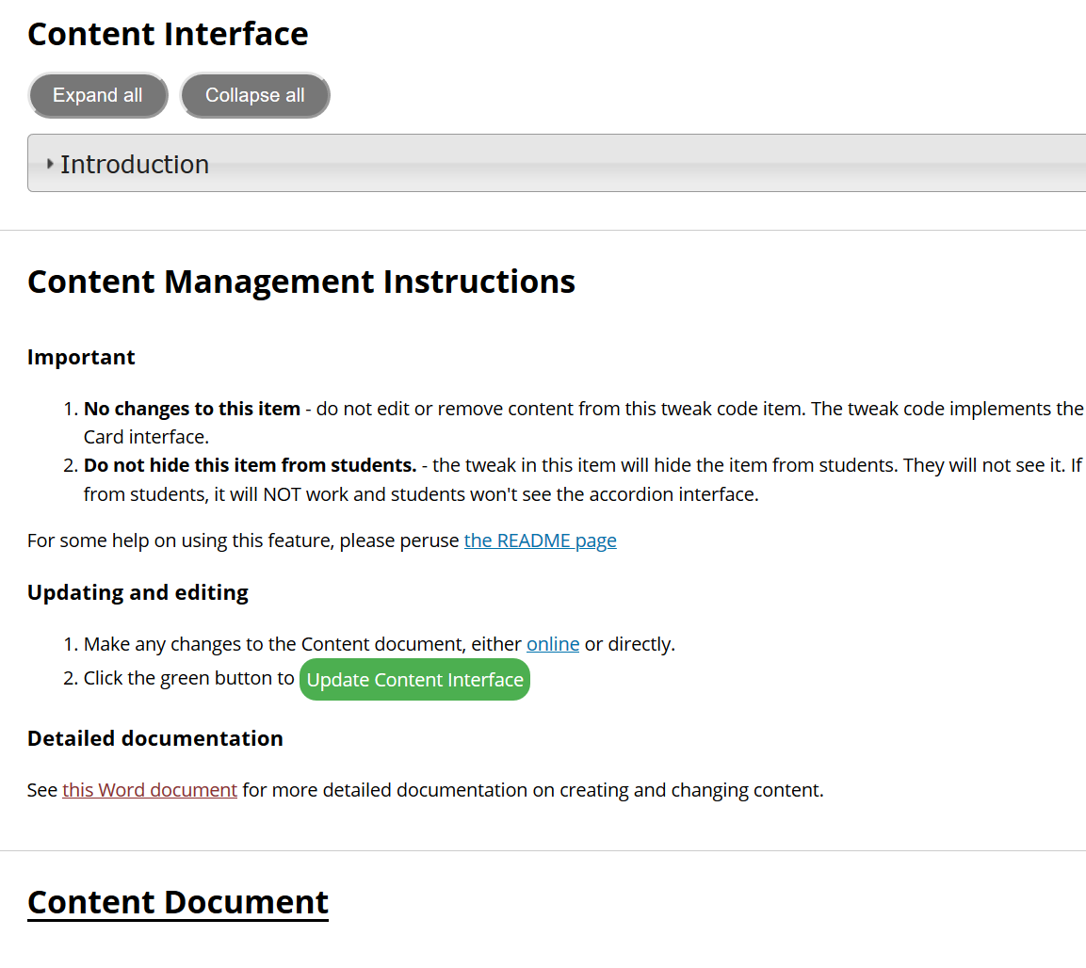

## Edit the Word document

All changes should be only be made in the Word document. Never, edit the Content Interface directly.

The Word document should be shared with you via OneDrive or SharePoint.

### Access the online version

If you have permission, you should be able to click on either of the links shown in the following image to see an online version of the Word document.

You can make changes in the online version and they will automatically be saved.

### Access the version on your computer

If you have sync’d [OneDrive with your Computer](https://support.office.com/en-us/article/choose-which-onedrive-folders-to-sync-to-your-computer-98b8b011-8b94-419b-aa95-a14ff2415e85) you can also edit the Word document via the Word application.

## Convert to HTML

Once you have made all the changes to the Word document you need to convert the Word document to HTML.

To do this you click the **Update Content Interface** button on the image above. This will start the conversion process and display something like the following image.

If the **PROGRESS** section is showing all green (and, perhaps some yellow) then the conversion process has been successful and the HTML version will be displayed.

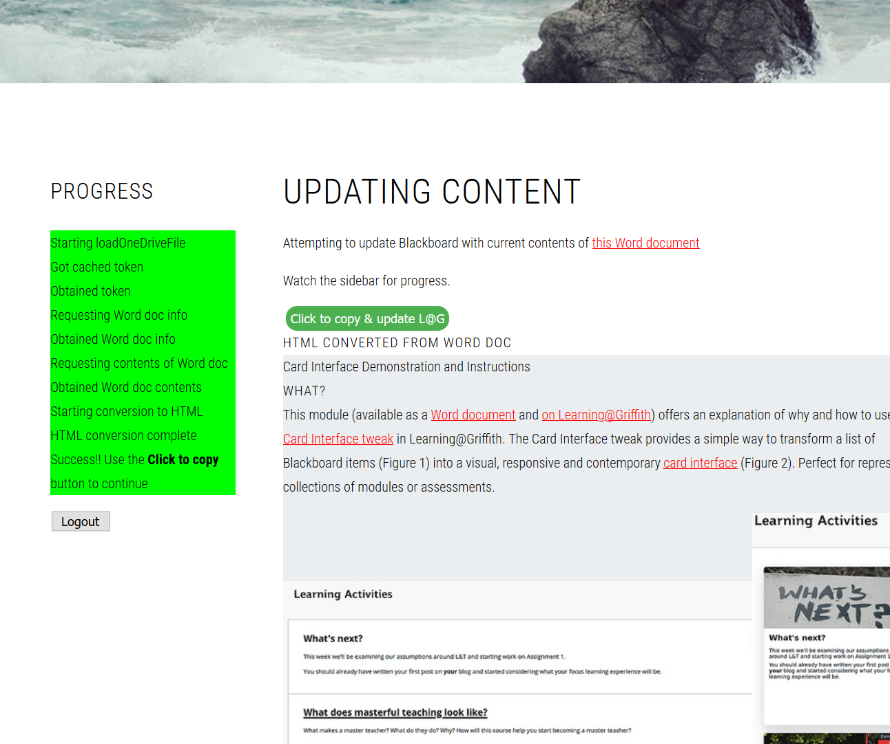

## Copy the HTML into the clipboard and return to Blackboard

Having converted the Word document to HTML, the next step is to make the change in Blackboard by pasting the HTML into Blackboard.

Do this by clicking on the **Click to copy & update L@G** button on the image above. This button will

1. Copy the HTML containing your updated content into your computer’s clipboard. (Ready for you to paste into Blackboard)
2. Take you back to Blackboard ready to edit the Blackboard item into which you need to paste the updated content.

If step #2 works, you should see something like the following image.

## Paste the updated content into Blackboard

Once you’re able to see something like the previous image, you are ready to paste the updated content into Blackboard.

### Press the HTML button

Because the updated content is in HTML format, you cannot just paste it into Blackboard. You need to press the HTML button pointed to in the previous image. You should then see something like the following image.

It shows the content of the Blackboard item in HTML. This is the content you will replace by

1. Delete all the content.
   1. Select all of the content by clicking in the *HTML code view* section and hittin CTRL-A (or Cmd A on a Mac).
   2. Hit the delete key to delete it
2. Paste in the updated content from the clipboard.
   1. Hit CTRL-V (or Cmd V on a Mac) to paste the clipboard contents.
3. Hit the *Update* button in the bottom right of the window.  
   This will take you back to the page shown in the previous image.
4. Hit the *Submit* button  
   This will take you back to the Blackboard page, which should be showing the updated content.

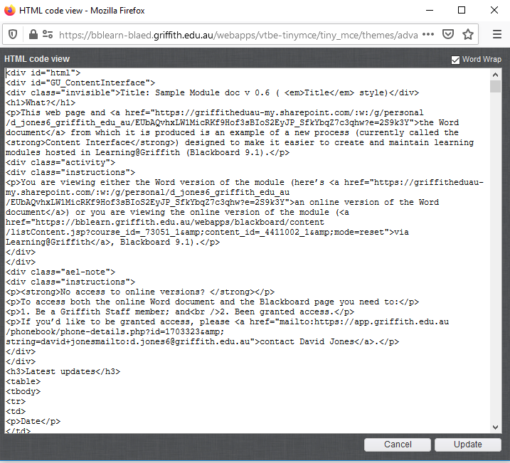

# How do you add/edit normal Word content: text, headings, tables and quotes

The following sections explains how to add/edit the type of content normally found in a Word document.

Each of the sections below explore a different content element, its style and how it is transformed online.

### Compare and constrast: Word and Blackboard

As you work through the examples in this section, it would be helpful to look at both the [Word document](https://griffitheduau-my.sharepoint.com/:w:/g/personal/d_jones6_griffith_edu_au/EUbAQvhxLW1MicRKf9Hof3sBIoS2EyJP_SfkYbqZ7c3qhw?download=1) and [Blackboard versions](https://bblearn.griffith.edu.au/webapps/blackboard/content/listContent.jsp?course_id=_73051_1&content_id=_4411002_1&mode=reset) of the document.

**Learn more about Word styles**

If you’re unfamiliar with using styles in Word documents, please refer to the plethora of online resources (e.g. [this one](https://shaunakelly.com/word/styles/tipsonstyles.html)). A quick search for *introduction word styles* should find most.

## Normal and the default text style

Any text that has a *Normal* style applied to it (this paragraph) or has a style that the content interface does not recognise, will be displayed as normal text.

Use of *italics*, **bold**, underline (doesn’t work), ~~strikethrough~~ and other character formatting will typically be represented in the online version, as shown in Figure 6

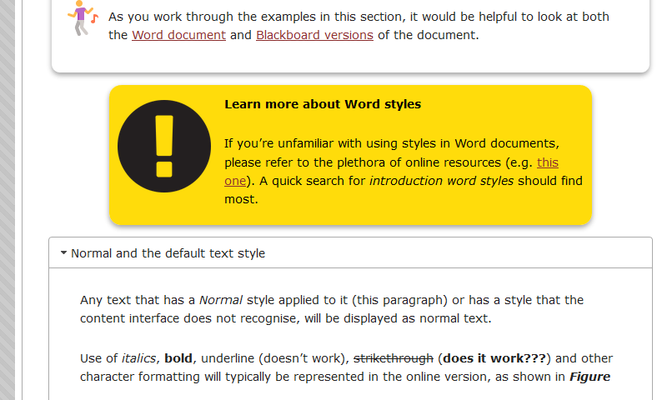

Figure 6 - Displaying normal text and some emphasis

## Headings and the accordion (Heading 2 style)

If you have viewed the Blackboard version of this document you will know that the content is transformed using [an accordion interface](https://en.wikipedia.org/wiki/Accordion_(GUI)). *Figure ??* is an example of what this section looks like online. It shows that each heading becomes an accordion header. Clicking on such a header allows its content to be expanded (shown) or collapsed (hidden).

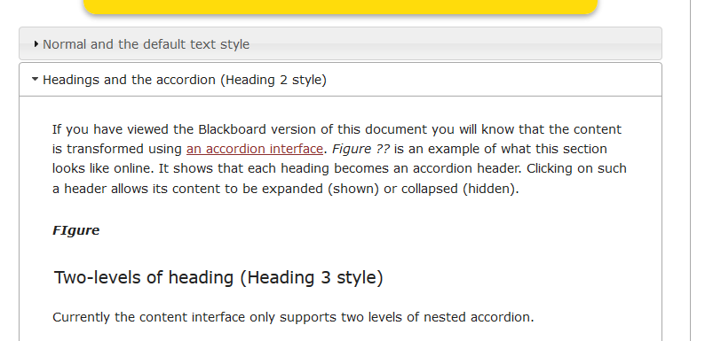

Figure 7 - Displaying headings, including accordions

### Two-levels of heading (Heading 3 style)

Currently the content interface only supports two levels of nested accordion.

Any text that has a *Heading 1* style applied to it becomes a top-level accordion. Any text with a *Heading 2* style applied will become a second-level accordion. Any text with lower heading styles (e.g. *Heading 3*) will just be displayed as a heading.

## Tables

Any Word table will be default be converted into a HTML table. Currently each HTML/online table is formatted using a single style (Figure 8).

|  |  |
| --- | --- |
| **Heading 1** | **Heading 2** |
| Hello | There |
| This | Is |
| A | Table |

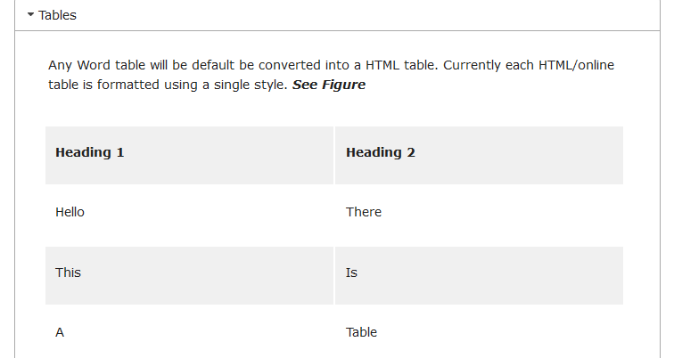

Figure 8 - Displaying tables

## Quotes

There is also support for quotes, references and bibliographies. In the following example (and on the next page), I’ve used my citation management software ([Zotero](https://www.zotero.org/)) to insert citations and the bibliography. This should work with other citation management software.

Any text with the style *Quote* or *Quotations* will be converted into a style HTML quote. If you compare the Word document version with the online version (see Figure 9), you will see that the quote styles are very different between media.

Solomon and Black (2008) argue that

In order to ‘try out’ new ways of thinking, we need to perceive ourselves as having some agency in or control over what we are doing. As long ago as 1976, Barnes identified a ‘performance climate’ in many classrooms (1976: 111) which detractce from such agency, creating a dynamic which disempowers pupils and prevents them from reflecting on their own thinking and pre-existing knowledge in order to relate new to old. The loss of collaboration with teachers in negotiating learning causes pupils to lok only for the answer that a teacher wants: ‘When a teacher assess what his pupils say he distances himself from their views, and allies himself with external standards which may implicitly devalue what the learner himself has constructed’ (1976: 111). In contrast, ‘when a teacher replies to his pupils, he is by implication taking their view of the subject seriously, even though he may wish to extend and modify it` (1976: 111): such interactions attribute a higher stats to the learners’ contributions, underlining their ownership of the learning that is going on. It is the dialogic quality of such interactions – questioning to invite surmise and the reorganisation of ideas, and (most importantly) collaborative discussion which picksup what is said and extends, modifies or even challenges it – that enables genuine construction of knowledge.

Johanson and Hasselbring (2018) – on another topic entirely – make the following argument

Because of this ideal of generality, the question of how specifically computational scientists should develop their software in a well-engineered way, would probably have perplexed a software engineer and the answer might have been: “Well, just like any other application software.

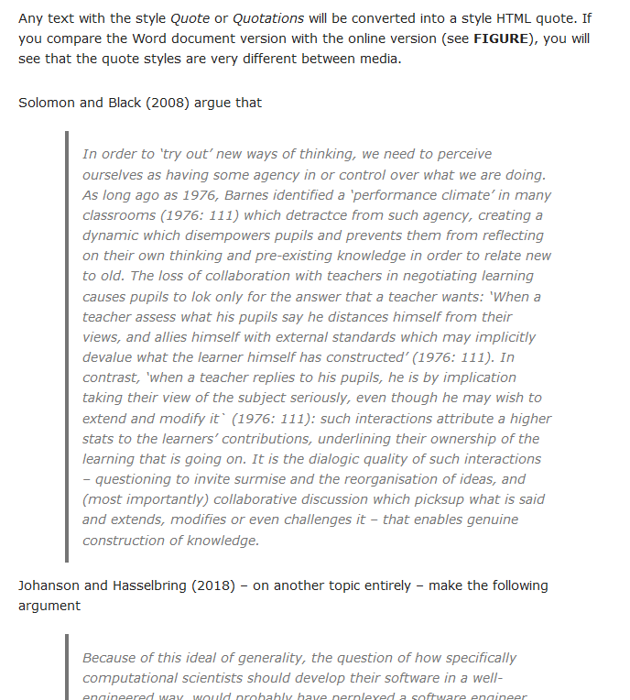

Figure 9 - Displaying quotes

## Bibliography

The following bibliography was created by [Zotero](https://www.zotero.org/) and inserted into this document. In just the same way as if you were using Endnote, Mendeley or some other form of citation management software (including manual copy and pasting). Figure 10 shows what it looks like in Blackboard.

Johanson, A., & Hasselbring, W. (2018). Software Engineering for Computational Science: Past, Present, Future. *Computing in Science & Engineering*. https://doi.org/10.1109/MCSE.2018.108162940

Solomon, Y., & Black, L. (2008). Talking to learn and learning to talk in the mathematics classroom. In *Exploring talk in school: inspired by the work of Douglas Barnes*. SAGE. Retrieved from https://e-space.mmu.ac.uk/90666/

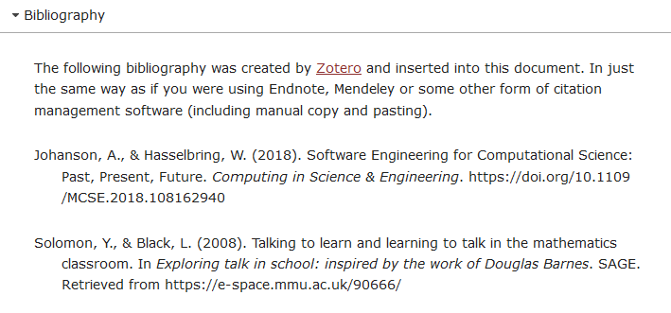

Figure 10 - Displaying a bibliograph (APA referencing)

## Footnotes

Microsoft Word enables [the creation of footnotes](https://support.microsoft.com/en-us/office/insert-footnotes-and-endnotes-61f3fb1a-4717-414c-9a8f-015a5f3ff4cb) [1]. The Content Interface now supports footnotes (endnotes not yet). But with some differences.

In Word, a footnote creates a reference with the detail at the bottom of the page. As shown in the following screenshot.

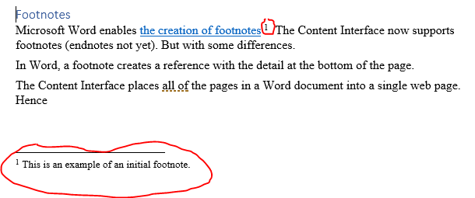

Figure - Footnotes in Word

The Content Interface places all of the pages in a Word document into a single web page. Changing the notion of “bottom of the page”. Due to this difference the Content Interface handles footnotes in two ways.

First, the content of footnotes appear as tooltips. i.e. if you roll your mouse over a footnote reference a small window pops up with the content of the footnote as shown in the following image.

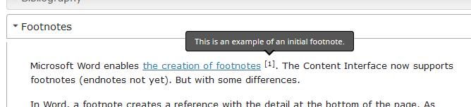

At the end of the document a new **Footnotes** section is added that contains a list of all footnotes throughout the Word document. e.g. the following image.

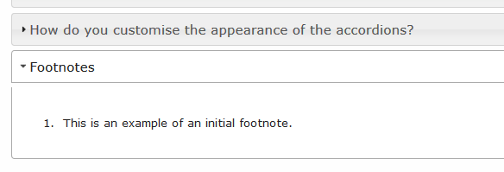

# How do you add/edit web content: images, links, video, embeddable content

The following sections explains how to add/edit the type of Web content, including: images; video and other embeddable content; and, links.

Each of the sections below explore a different content element, its style and how it is transformed online.

### Compare and constrast: Word and Blackboard

As you work through the examples in this section, it would be helpful to look at both the [Word document](https://griffitheduau-my.sharepoint.com/:w:/g/personal/d_jones6_griffith_edu_au/EUbAQvhxLW1MicRKf9Hof3sBIoS2EyJP_SfkYbqZ7c3qhw?download=1) and [Blackboard versions](https://bblearn.griffith.edu.au/webapps/blackboard/content/listContent.jsp?course_id=_73051_1&content_id=_4411002_1&mode=reset) of the document.

**Learn more about Word styles**

If you’re unfamiliar with using styles in Word documents, please refer to the plethora of online resources (e.g. [this one](https://shaunakelly.com/word/styles/tipsonstyles.html)). A quick search for *introduction word styles* should find most.

## Images



Figure 12 - Picture floating to right online

Feel free to insert images directly into the document. If you apply the *PictureRight* style to an image (e.g.

Figure 12) it will float off to the right of most text when viewed on the Web. But it won’t behave like this in the Word document (because image placement and text wrapping in Word is hard).

For a *PictureRight* image, being much bigger than 300px can cause problems (see *Image Size* below for more information)



Figure 13 - An image that will be centred when viewed online

## Image size – resize before inserting into Word

If you resize an image using Word, that size will not translate to the Web site. For example, take note of the size of Figure 14 in [the Word document](https://griffitheduau-my.sharepoint.com/:w:/g/personal/d_jones6_griffith_edu_au/EUbAQvhxLW1MicRKf9Hof3sBIoS2EyJP_SfkYbqZ7c3qhw?e=2S9k3Y) and compare it to the size [on the Web](https://bblearn.griffith.edu.au/webapps/blackboard/content/listContent.jsp?course_id=_73051_1&content_id=_4411002_1&mode=reset).

If you have a big image, you will need to change the size of the image before you place it into Word (otherwise it appears in Blackboard as its original size). For example, see Figure 14.

There is a [free online picture resize](https://www.google.com/url?sa=t&rct=j&q=&esrc=s&source=web&cd=2&cad=rja&uact=8&ved=2ahUKEwifmK_z4rfgAhWQYH0KHTIbDrYQFjABegQICRAB&url=http%3A%2F%2Fwww.picresize.com%2F&usg=AOvVaw2McMuXErV26jx_kLn4O1HS) service (or there are other options on most platforms) to resize bigger images.

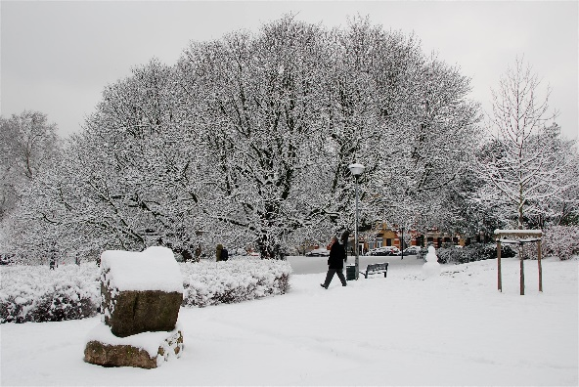

Figure 14 - An image that looks small in Word, but big online

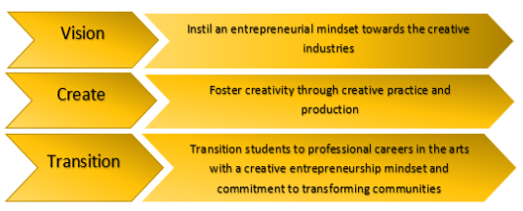

Figure 15 - My caption

[Link to demo](https://bblearn-blaed.griffith.edu.au/webapps/blackboard/content/listContentEditable.jsp?content_id=_4411002_1&course_id=_73051_1)

## Links

Rather than include URLs in the text – such as – see https://www.flickr.com/photos/topsteph53/4192354425/ for the original version of the photo on the previous page.

Instead [create or edit a hyperlink](https://support.office.com/en-us/article/create-or-edit-a-hyperlink-5d8c0804-f998-4143-86b1-1199735e07bf) (that link takes you to Microsoft’s explanation of how to create or edit a hyperlink) such as [view the original big photo](https://www.flickr.com/photos/topsteph53/4192354425/).

## Embedding YouTube videos and beyond

If you want to embed a YouTube video in your web page (or any other type of web resource (e.g. a Google form, Vimeo video etc), you need to

1. Copy the embed code from the source
2. Paste the embed code into your Word document
3. Apply the *Embed* style to the embed code you just pasted

### For example, YouTube

**1. Copy the embed code from YouTube**

[This support resource](https://support.google.com/youtube/answer/171780?hl=en) from YouTube explains how to copy the embed code for a YouTube video.

**2. Paste the embed code into your Word document**

When those instructions are used on [this YouTube video](https://www.youtube.com/watch?v=g6V38GlfnJw) it produces the following embed code.

<iframe width="560" height="315" src="https://www.youtube.com/embed/rQmFY_C9hAU" frameborder="0" allow="accelerometer; autoplay; encrypted-media; gyroscope; picture-in-picture" allowfullscreen></iframe>

On the web, this code will NOT be converted into a video.

This is because it has the *Normal* style applied to it in the Word document.

**3. Apply the *Embed* style to the embed code**

This next embed code has the *Embed* style applied. In this Word document, the *Embed* style uses a different font and size to make clear that it is a different style. When converted to the Web it will appear as a YouTube video

<iframe width="560" height="315" src="https://www.youtube.com/embed/rQmFY_C9hAU" frameborder="0" allow="accelerometer; autoplay; encrypted-media; gyroscope; picture-in-picture" allowfullscreen></iframe>

## Readings

If you want to have something appear as a reading that is clearly separate from the rest of the text then apply the *Reading* style. As I’ve done with the following content. Not the different background colour that is part of the *Reading* style. This change in colour is used to more clearly indicate what is or is not a reading.

Current practice is to have a title for the reading (or activity that is not styled *Reading*). As shown below.

### Is XKCD funny?

Xkcd is a web-comic with the tag line "A webcomic of romance, sarcasm, math, and language”. Visit the [xkcd website](https://xkcd.com/) and view today’s comic. Don’t forget to move your mouse over the comic. Does the content and topic of today’s topic seem humorous to you? Why? Why not?

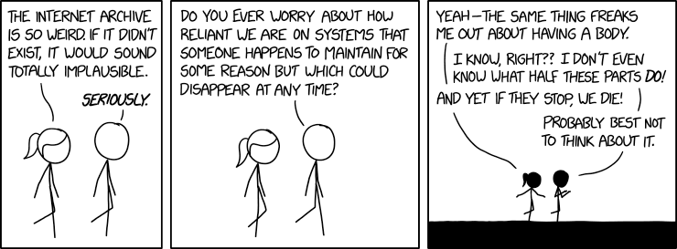

# How do you use automatically updated University dates?

If you wish to include the date for an assignment you might write

Assignment 1 due 5pm on Wednesday Week 5 (17 March 2019).

**Problem:** What happens when your course content gets rolled over into another trimester or study period? A study period that has different dates. Almost certainly Wednesday Week 5 will no longer be 17 March 2019.

The solution to this problem is to use the *University Date* style to tell the Content Interface to insert a date specific to the course’s current trimester/study period.

## Examples

For example, Wednesday Week 5 written using the *University Date* style will have the trimester specific date for Wednesday Week 5 inserted in brackets and appear on the Web as Wednesday Week 5 (15 August 2020).

The following table includes some examples (best viewed in Blackboard) and the image below is a screenshot of what it looks like in Blackboard.

|  |  |
| --- | --- |
| **Word** | **Web** |
| Monday Week 1 | Monday Week 1 |
| Wednesday Week 1 | Wednesday Week 1 |
| Thursday Week 11 | Thursday Week 11 |

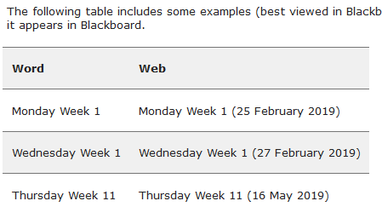  
Figure 16 - Table showing how University Date is automatically updated

## How to do it

1. Write out the date using the format - *Day* Week *NumWeek*  
   Where *Day* is replaced by a day of the week (capitalisation not important) and *NumWeek* is replaced by a number representing the week of the trimester/study period.  
   e.g. Thursday Week 4
2. Apply the *University Date* style to the date you wrote.   
   If using this document, the date text should be red in colour and use the Courier New font (e.g. Thursday Week 4). The change in font and colour is intended to help you recognise the difference when editing the Word document.

# How do you add/edit study guide content: readings, activities, notes

The following sections explains how to add/edit the type of content design specifically for learning or study content. Currently, it explains the creation of elements, including:

* Readings – indicate a (textbook) reading required of students;
* Activities – indicate the student should engage in an activity; and,
* Notes – indicate an important note that the student should be aware of.

Each of the sections below explore a different content element, its style and how it is transformed online.

### Compare and constrast: Word and Blackboard

As you work through the examples in this section, it would be helpful to look at both the [Word document](https://griffitheduau-my.sharepoint.com/:w:/g/personal/d_jones6_griffith_edu_au/EUbAQvhxLW1MicRKf9Hof3sBIoS2EyJP_SfkYbqZ7c3qhw?download=1) and [Blackboard versions](https://bblearn.griffith.edu.au/webapps/blackboard/content/listContent.jsp?course_id=_73051_1&content_id=_4411002_1&mode=reset) of the document.

**Learn more about Word styles**

If you’re unfamiliar with using styles in Word documents, please refer to the plethora of online resources (e.g. [this one](https://shaunakelly.com/word/styles/tipsonstyles.html)). A quick search for *introduction word styles* should find most.

## Activities

An activity will be displayed on the web in a way different to a reading. However, you specify an activity much the same way. Create the text and then apply the *Activity* style to it. As seen below, the *Activity* style has a different background colour (blue) to highlight the different style.

### A dummy activity

This is an example of an activity. If you bring up the “styles” or “Apply Styles” window in Word, when you click on this paragraph you should see that it’s an *Activity* style.

## Notes

Any text that has the *Note* style applied will appear currently in a quite obvious warning box when displayed online (and yellow background when displayed in Word). This approach has already been used in this guide to highlight important points

**Don’t over use notes**

There is probably a danger of overuse of the note style.

# Integrating Blackboard items (quizzes, discussion forums, blogs etc.)

Blackboard provides an array of content, assessment, and tool services that can be used in a Blackboard course site. For example, discussion forums, quizzes, assessments etc. It is common to want to provide a link to these Blackboard resources/services. For example,

* “Go to our tutorials via [the Collaborate Ultra link](Collaborate%20Ultra) in the course menu”
* The Card Interface is another tweak for Blackboard that complements that Content Interface. Find out more in [the Card Interface Help section](card%20interface%20help).

The content interface offers two different ways of linking to Blackboard resources or services:

1. Blackboard Menu Link; or,
2. Blackboard Content Link.

**The links only work in Blackboard**

Links you create this way will not work correctly in Word. They will only work correctly in Blackboard.

It’s only in Blackboard that the Content Interface tweak is able to find the proper links and use them.

**They keep working after a course copy**

If a course copy includes all the relevant information, then these links will be automatically updated to work on the new course site.

## Blackboard Menu Link

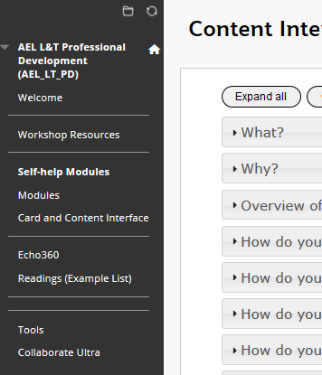

On the left hand side of every Blackboard course there will be a [Course Menu](https://bbhelp.cit.cornell.edu/the-course-menu/). The Course Menu provides direct access to important parts of the course site. A *Blackboard Menu Link* allows you to create a link in Word that links to one of the items in the Course Menu.

For example, when viewed in Blackboard [this link](Welcome) will take you to the same location as the **Welcome** in the Course Menu image shown to the right.

### How to create a Blackboard Menu Link

1. Identify the name of the menu item that you want to link to.  
   You need the exact name. **welcome** is not the same as **Welcome**
2. [Create a hyperlink](https://www.wikihow.com/Insert-a-Hyperlink-in-Microsoft-Word) in Word using the name of the menu item as the address.  
   e.g. the address for [this link to the Welcome menu item](Welcome) is just **Welcome. (**A quick way to create a hyperlink is to select the text you wish to act as the link and hit **CTRL-K** (CMD-K on Apple computer).)
3. Apply the Word style *Blackboard Menu Link* to the link you just created.  
   Select the entire link and then use the *Styles* section on the *Home* tab. ([more advice on applying styles](https://support.microsoft.com/en-us/office/apply-styles-f8b96097-4d25-4fac-8200-6139c8093109))

## Blackboard Content Link

The Blackboard Course Menu only provides links to the sections of your course site. Not to items within those sections. For example, the course menu will provide a link to the *Assessment* section but won’t provide a link to the first assessment task. Sometimes you want to link to the first assessment task. Sometimes you want to link to an item somewhere within your Blackboard course site.

This is when you use the *Blackboard Content Link* style.

For example, when on Blackboard you can view [the *Maximising Mark Centre* workshop resources](maximise). Which is an item underneath the *Workshop Resources* section of this course site.

### How does it work?

If you use Word to examine the link to the *Maximising Mark Centre* resources you will see something like the following image.

It shows that the *address* (circled in red) for this link is **maximise**. By itself this link won’t work as expected.

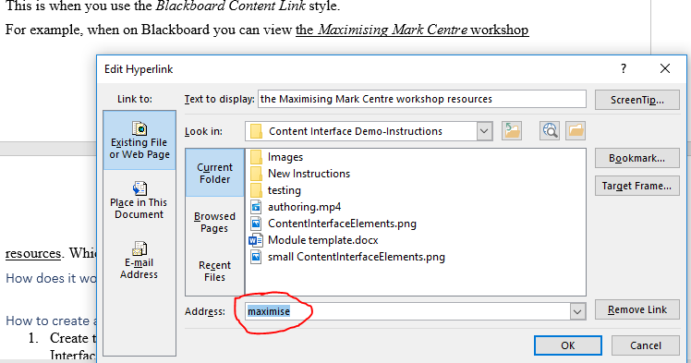

But, if you had permission to *edit* this page you would find that it includes an item with the name **maximise** (see the following screenshot). This item is a [Blackboard course link](https://help.blackboard.com/Learn/Instructor/Course_Content/Create_Content/Create_Course_Materials/Link_to_Content_and_Tools#what-is-a-course-link_OTP-0). It has been created to provide a link the *Maximising Mark Centre workshop* resources.

When the Content Interface finds a *Blackboard Content Link* it looks for an item on the following page that has a name that matches the link address. In this case, the address is **maximise** so it looks for an item on the page called **maximise**.

If it finds a matching item, then the link is modified to point to the same address as used by the Blackboard item.

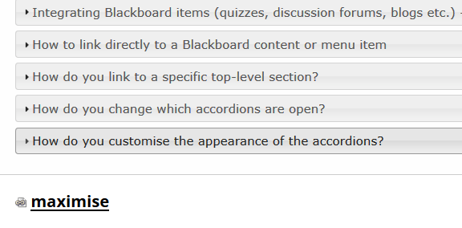

### How to create a Blackboard Content Link

There are two broad steps to complete. The order in which they are completed is unimportant, however, both steps are required.

* Create and style the link in the Word document.
  + [Create a hyperlink](https://www.wikihow.com/Insert-a-Hyperlink-in-Microsoft-Word) in Word with an address you know to be unique to the Blackboard page. A simple address is often best (e.g. **maximise**).
  + Apply the *Blackboard Content Link* style to the entire link.  
    ([more on applying styles in Word](https://support.microsoft.com/en-us/office/apply-styles-f8b96097-4d25-4fac-8200-6139c8093109))
* Add the matching content type to the Blackboard page.
  + Select the particular [Blackboard Content type](https://help.blackboard.com/Learn/Instructor/Course_Content/Create_Content/Create_Course_Materials/Types_of_Course_Content) that will provide you with the link you need.  
    The [*Course Link*](https://help.blackboard.com/Learn/Instructor/Course_Content/Create_Content/Create_Course_Materials/Link_to_Content_and_Tools#what-is-a-course-link_OTP-0)content type is typically the most useful.
  + Make sure the name of the new content type matches the address of the link you created in the Word document.

## Links are (not currently available)

Both the *Blackboard Menu Link* and *Blackboard Content Link* styles only work if they are able to match the address of the link in Word with an item on the Blackboard course site. If they are unable to make this match **(not currently available**) will be inserted into the link. For example, the following images.

To fix this problem you will need to ensure that the appropriate Blackboard item exists and its name matches exactly that of the address created in Word.

|  |  |
| --- | --- |
| Figure - Blackboard Menu Link not working | Figure - Blackboard Content Link not working |

**Beware Word special characters – copy and paste**

Matching the link address and the item name is an exact match. *Maximise* is different to *maximise*.

Microsoft Word automatically replaces some text characters with others. For example, [smart quotes](https://support.microsoft.com/en-us/office/smart-quotes-in-word-702fc92e-b723-4e3d-b2cc-71dedaf2f343) and [hyphens and dashes](https://support.microsoft.com/en-au/help/284897/autoformat-converts-some-hyphens-to-long-dashes-in-word). This can create some less than apparent differences.

When adding the content type to the Blackboard page, rather than type the name, copy and paste it from Word.

**Beware creating links in the online version of Word**

Experience suggests that the online version of Word doesn’t create links the same way as the desktop Word application.

Integrating with the Blackboard “Review Status” feature

The Blackboard Review Status feature provides a way for students to mark items as reviewed and for teaching staff to track how students have marked items as reviewed. It can be used by students to help track what they have looked at or completed. It provides teaching staff with an overview of how students are choosing to engage with the contents of a course site.

Integrating the Content Interface with the *Review Status* feature allows specific accordions (sections) to use *Review Status*.

## How it works

*When not reviewed the accordion title shows NOT REVIEWED and there is a MARK REVIEWED button*

*When it is reviewed….*

## How to use it

1. Use contentWithCards
2. Change heading to Blackboard heading
3. Add content item with matching name
4. Enable review status

# How to link directly to a Blackboard content or menu item

This approach allows you to embed a link to

1. a Blackboard content item; or,  
   Such as [this link](Take%20a%20quiz) to a quiz on this Blackboard page. (The same quiz linked to in the last section)
2. a Blackboard course menu item.  
   Such as [this link](Enhancing%20modules%20with%20the%20Card%20and%20Content%20Interface%20Tweaks) to a presentation introducing the Card and Content Interfaces. You should be able to see the link in the menu to the left of the page. The link title is **Enhancing modules with the Card and Content Interface Tweaks**.

There are three steps to the process as explained by the following.

## 1. Blackboard: Identify the title of the link

This process only works if the link you will use already exists on the Blackboard page. If it exists, that link will have a title. There are two types of links you can use.

### Content Item link

Figure 19 (below) shows a version of this Blackboard content page. It shows four content items (Content Interface; Chat about the content interface; Take a quiz; and, Testing). The last three of these content items are links (as indicated by them being underlined). If you click on these links you will be taken to a different page.

The title of a Content Item link is what you can see. For example, I want to link to the quiz on this page. The title for this link is **Take a quiz**

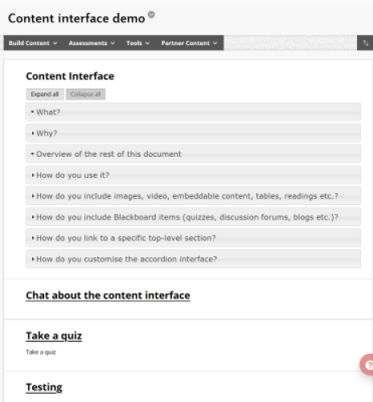

Figure - Blackboard Content Page - showing Content Items

### Menu Item link

Figure 20 below shows part of this page as well. It’s focus is on the course menu to the left – the section with the black background.

The Course Menu includes a number of links. The titles of these links is visible.

I’d like to link to the presentation about the Card and Content Interface Tweaks. The title of the course menu item link to this presentation is **Enhancing modules with the Card and Content Interface Tweaks**

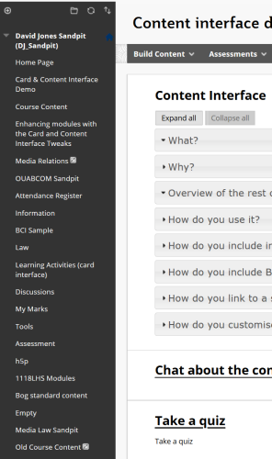

Figure - Example Course Menu

## 2. Word document: Create a link using the title

Now that you know the title of the Blackboard menu or content item, it’s time to create a link to that item. To do this you use the standard process in Word to [create or edit a hyperlink](https://support.office.com/en-us/article/create-or-edit-a-hyperlink-5d8c0804-f998-4143-86b1-1199735e07bf) and use the title of the link (see the section above) as the actual link.

For example, I’m creating links to

* [the quiz](Take%20a%20quiz); and,  
  So the link uses **Take a quiz** as the link.
* [the presentation](Enhancing%20modules%20with%20the%20Card%20and%20Content%20Interface%20Tweaks).

Figure 21 below shows what was done to insert the link to the presentation above.

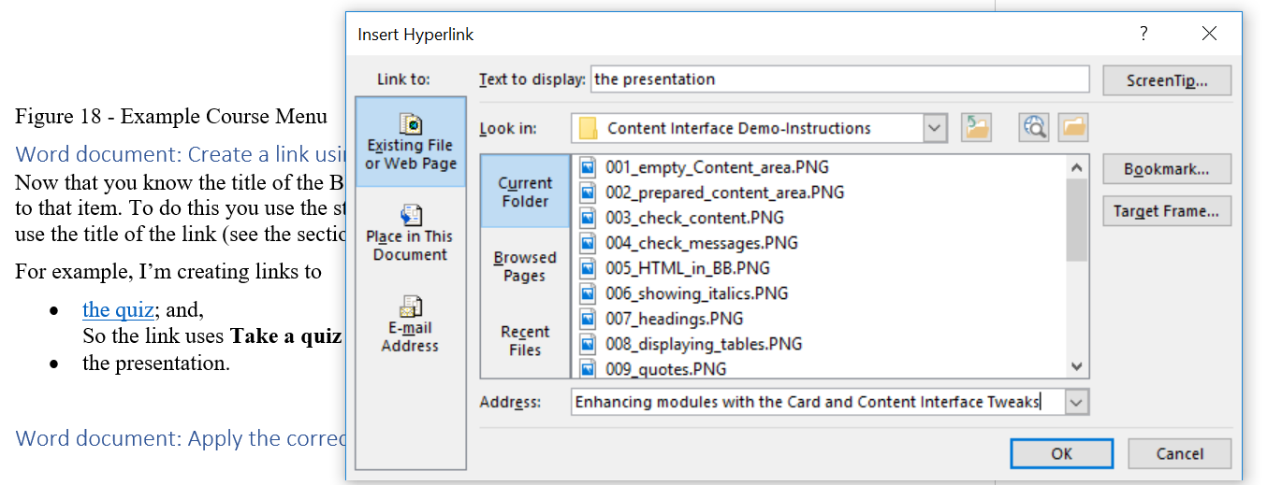

Figure - Inserting a link to the presentation

## 3. Word document: Apply the correct style to your link

The last step is to apply a Word style to the link(s) that have just been created. It is these styles that enable the “title” link to be transformed into something you can click on.

To do this you use [the standard approach](https://support.office.com/en-us/article/apply-styles-f8b96097-4d25-4fac-8200-6139c8093109) (select the text you wish to style and choose the style) to applying styles in Word and you apply one of two styles, matching the two types of elements discussed above. The two styles are:

1. Blackboard Content Link; and,
2. Blackboard Menu Link

For example, I’m creating links to

* [the quiz](Take%20a%20quiz); and,  
  Which is a Content Item so needs to have the Blackboard Content Link style applied.
* [the presentation](Enhancing%20modules%20with%20the%20Card%20and%20Content%20Interface%20Tweaks).  
  Which is a Menu Item so needs to have the Blackboard Menu Link style applied.

Figure 22 below illustrates the process of applying the **Blackboard Menu Link** to the presentation link above.

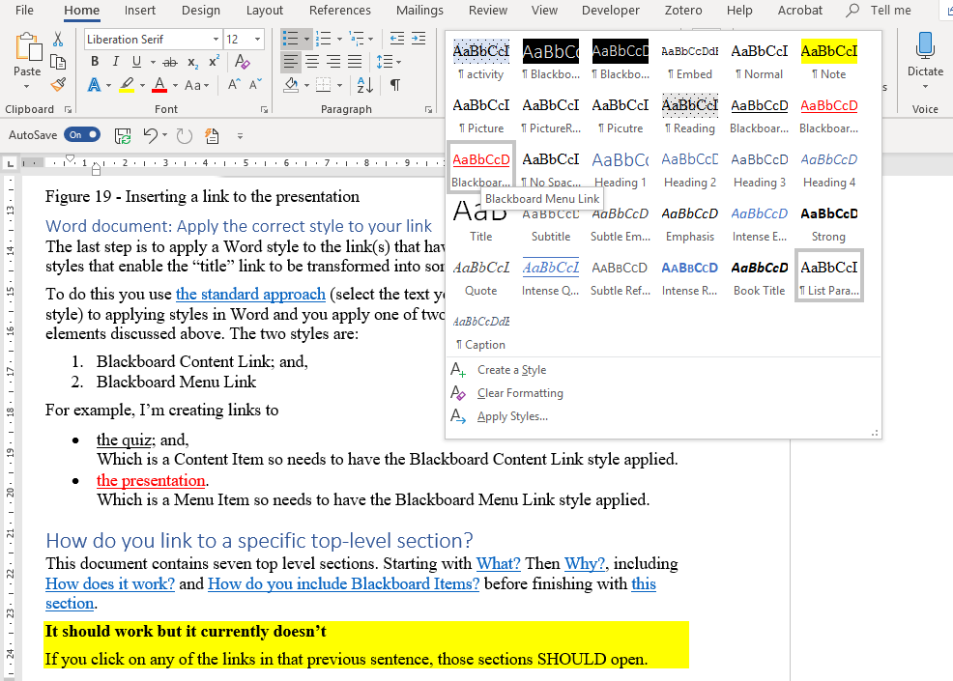

Figure - Applying a style to a Blackboard Menu Item link

# How do you link to a specific top-level section?

This document contains seven top level sections. Starting with [What?](https://bblearn-blaed.griffith.edu.au/webapps/blackboard/content/listContentEditable.jsp?content_id=_4411002_1&course_id=_73051_1&content_id=_4411036_1#1) Then [Why?](https://bblearn-blaed.griffith.edu.au/webapps/blackboard/content/listContentEditable.jsp?content_id=_4411002_1&course_id=_73051_1&content_id=_4411036_1#2), including [How does it work?](https://bblearn-blaed.griffith.edu.au/webapps/blackboard/content/listContentEditable.jsp?content_id=_4411002_1&course_id=_73051_1&content_id=_4411036_1#4) and [How do you include Blackboard Items?](https://bblearn-blaed.griffith.edu.au/webapps/blackboard/content/listContentEditable.jsp?content_id=_4411002_1&course_id=_73051_1&content_id=_4411036_1#5) before finishing with [this section](https://bblearn-blaed.griffith.edu.au/webapps/blackboard/content/listContentEditable.jsp?content_id=_4411002_1&course_id=_73051_1&content_id=_4411036_1#7).

**It should work but it currently doesn’t**

If you click on any of the links in that previous sentence, those sections SHOULD open. However, there is currently a bug that needs to be explored.

This method does work when coming from elsewhere. It doesn’t work when trying to link within the same document. **To be fixed.**

### Why?

This allows you to direct the reader’s directly to a particular top-level section. Either from a link within the module (like those above) or in an email or discussion forum post. e.g. a response to a student question that is answered within the section.

### How?

You do this by adding **#num** to the end of the Web location (URL) for the module. Where **num** is a number representing the sequence of the top level section. i.e. the very first section would be **#1**. The third section would be **#3** etc.

For example the URL for this page is

<https://bblearn.griffith.edu.au/webapps/blackboard/content/listContentEditable.jsp?content_id=_4411002_1&course_id=_73051_1&content_id=_4411036_1>

to link to the **Why?** section (the 2nd section) you add **#2** to the end of the URL

<https://bblearn.griffith.edu.au/webapps/blackboard/content/listContentEditable.jsp?content_id=_4411002_1&course_id=_73051_1&content_id=_4411036_1#2>

You can now use this link in a document, message or how you would like.

# How do you change which accordions are open?

By default, the content you have provided will be displayed in an accordion interface with the first level 1 accordion open and ready to be read. All the other level 1 accordion sections will be closed. Figure 23 is an example.

**There are two levels of accordions**

The Content Interface supports two levels of nested accordions.

All the accordions you can see in Figure 23 are level 1 accordions. These are specified using a *Heading 1* style in the Word document.

Level 1 accordions can include further accordion sections. Each of these further accordion sections are Level 2 accordions. Specified in Word using a *Heading 2* style.

### Options for changing which accordions open

Apart from the default option (the first level 1 accordion is open) there are three other options how the content is displayed, including

1. Expand all the level 1 accordions.
2. Collapse all the level 1 accordions.
3. Specify which level 1 accordion to open.

The following sub-sections explain how to use these options.

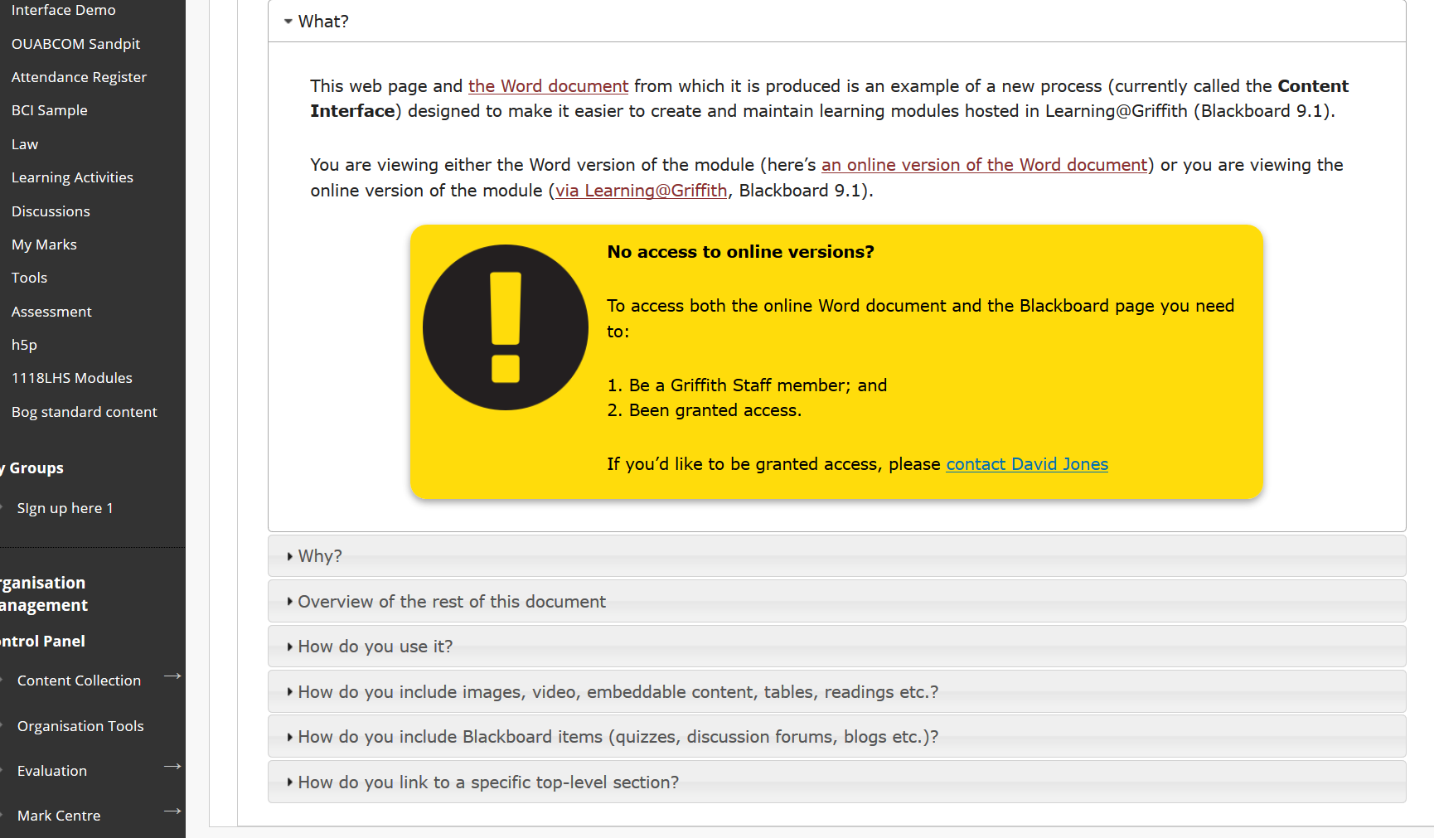

Figure 23 - Example default open

## Expand all the level 1 accordions

To have the Content Interface display with all Level 1 accordions open you add the parameter **expandAll** to the title of the Content Interface item as shown in Figure 24 below. Figure 25 shows a Content Interface with all Level 1 accordions open.

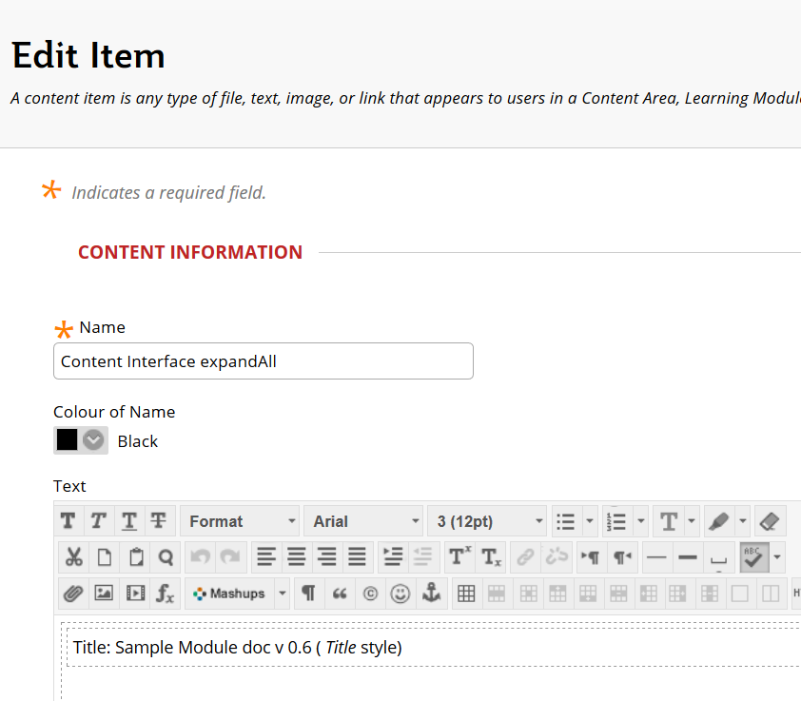

Figure - Adding the expandAll parameter to the Content Interface item title

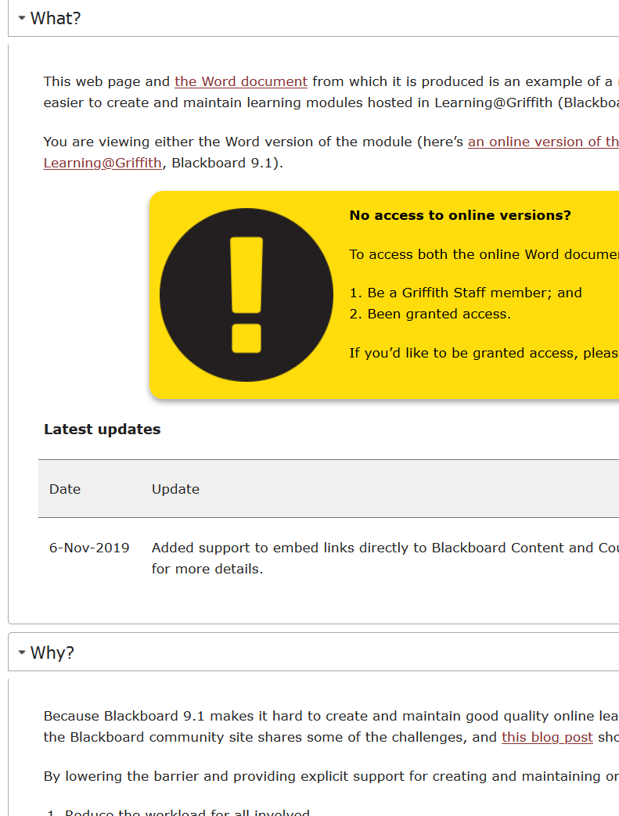

Figure - Content Interface with all Level 1 headings open

## Collapse all the level 1 accordions

To have the Content Interface display with all Level 1 accordions closed you add the parameter **collapseAll** to the title of the Content Interface item as shown in Figure 25 below. Figure 27 shows a Content Interface with all Level 1 accordions open.

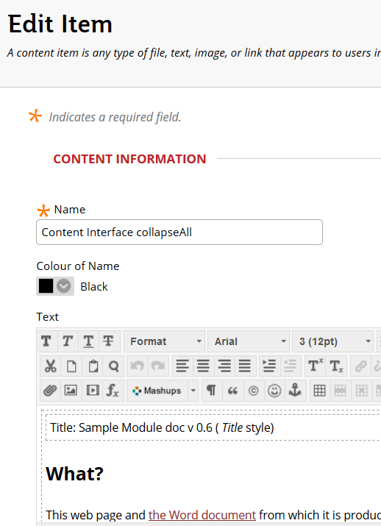

Figure - Adding the collapseAll parameter to the Content Interface title

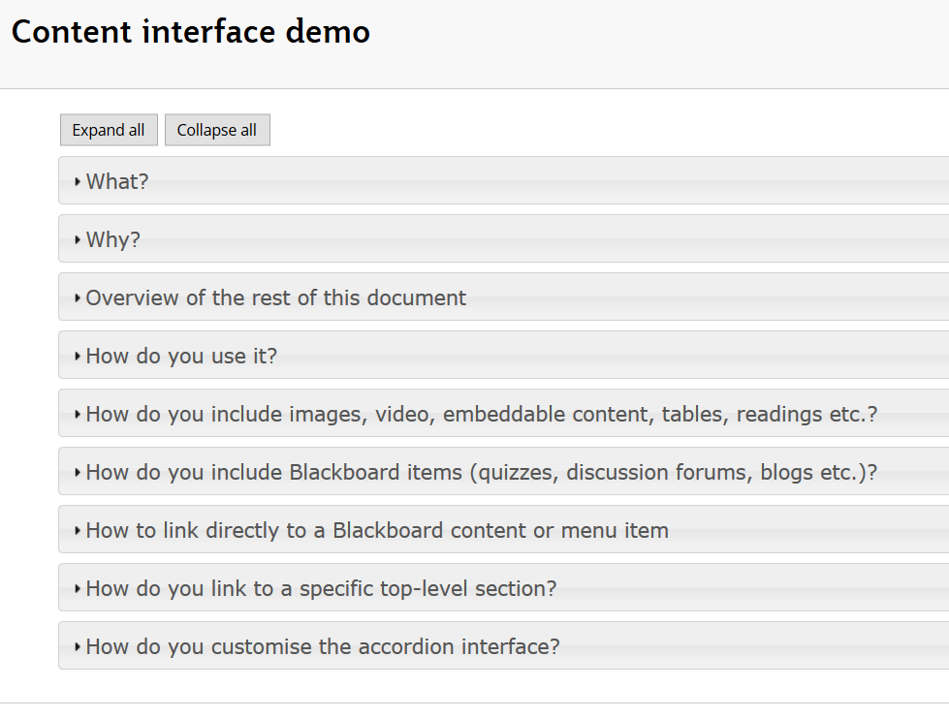

Figure - Content Interface with all Level 1 accordions closed

## Specify which level 1 accordion to open

If you would like to open just one of the Level 1 accordions, you need to

1. Figure out the number of the Level 1 accordion you wish to open? (e.g. 2nd, 3rd, 4th etc).
2. Add the **expand=X** parameter to the Content Interface title.  
   Where you replace **X** with the number. e.g. **expand=3** to open the third Level 1 accordion by default.

Figure 28 shows **expand=3** being added to the Content Interface item’s title.

Figure 29 shows the Content Interface with the third Level 1 accordion open.

**Open and the top of the visible page**

When the Content Interface shown in Figure 29 first appeared on the screen it did not look like what is shown in Figure 29.

Instead, the open Level 1 accordion (the third one on the page) was displayed at the top of the visible page.

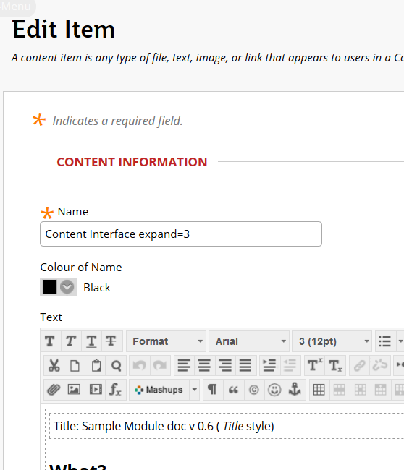

Figure - Adding expand=3 to the Content Interface item's title

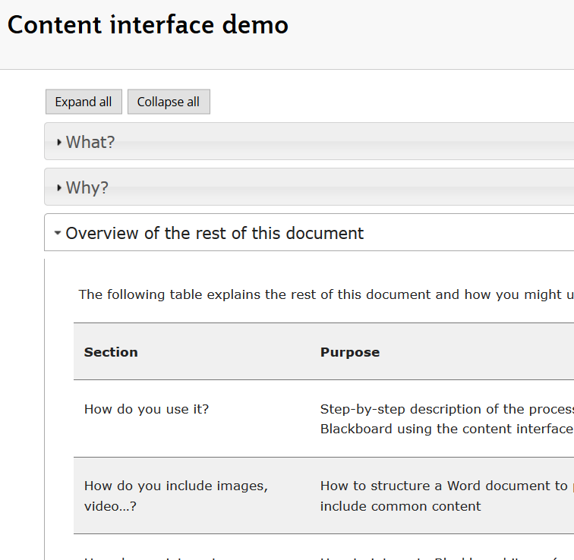

Figure - Content Interface with the third Level 1 accordion open

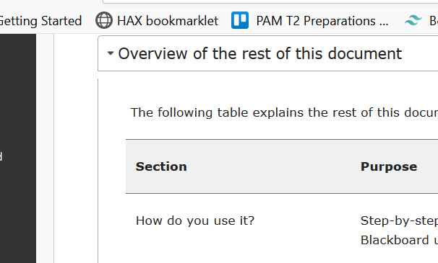

Figure - Showing that open Level 1 accordion at the top of the browser

# How do you customise the appearance of the accordions?

Figure 31 shows two versions of the same document (this one) displayed using the Content Interface. The major difference between the two versions is the “theme” being used to display the accordion interface elements. Note the difference in colour between the different accordion elements.

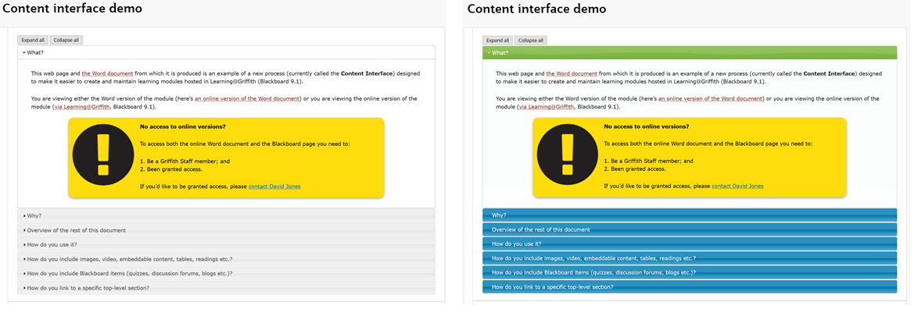

Figure 31 - Same Content Interface, but different styling

The left-hand version has grey backgrounds for accordions that are not active. The active accordion element has a white background.

The right-hand version has a blue background for non-active accordions. The active accordion element has a green background.

## Technical Background

The Content Interface uses [jQuery](https://jquery.com/) – “a fast, small, and feature-right Javascript library” - to implement the accordion interface. jQuery supports the notion of themes, which can be used to modify how interfaces built with jQuery are displayed.

The visible change in colours illustrated in Figure 31 is done by changing the jQuery theme being used.

The [jQuery Theme Roller](https://jqueryui.com/themeroller/) is a website that allows you to create, customise and download jQuery themes – it allows you to roll your own.

## How to customise the Content Interface using jQuery themes

The following provides a high level description of how to customise the Content Interface using jQuery themes.

### 1. Identify, create or customise a jQuery

Use the [jQuery Theme Roller](https://jqueryui.com/themeroller/) (or other means you discover) to create your theme. You can choose from one of the themes available in the Gallery, create your own theme, or customise an existing theme.

See the “Using jQuery UI ThemeRoller” page for more See the [“Using jQuery UI ThemeRoller” page](https://learn.jquery.com/jquery-ui/themeroller/) for more advice on how to do this.

### 2. Download the theme CSS file

Once you have customised your theme, the jQuery Theme Roller provides a *Download Theme* option. This allows you to configure and download a file (a CSS file). This file implements your theme. Save it to your local hard drive.

When configuring the theme CSS file you specify which elements of the theme to include. To be safe, include them all.

However, if you’d like you can select only those elements associated with the accordion widget – the only jQuery widget used by the Content Interface.

### 3. Upload the theme CSS file to a web server

To use the theme within Blackboard, the CSS file must be uploaded onto a Web server.

The [Blackboard Content Collection](https://help.blackboard.com/Learn/Student/Content/Content_Collection) is one possibility.

### 4. Modify the Content Interface tweak to use your theme’s CSS file

The [Content Interface tweak](https://github.com/djplaner/Content-Interface-Tweak/blob/master/tweak.html) is the collection of HTML and Javascript that is inserted into a Blackboard Content Area to implement the Content Interface. By default, this tweak uses the following CSS

<link rel="stylesheet" href="**//code.jquery.com/ui/1.12.1/themes/smoothness/jquery-ui.css**" />

To use your theme’s CSS file, replace the link – the bolded text above – with the URL for your theme’s CSS file.

For example, the blue/green theme shown in Figure 31 was produced using the following

<link rel="stylesheet" href="https://djon.es/gu/jui/jquery-ui.css" />

**Checking your CSS file’s URL**

One way to check that you have the correct URL for your theme’s CSS file is to copy and paste the URL into your web browser and try to visit the page.

For example, try to click on (or copy and paste) the URL for the blue/green theme - <https://djon.es/gu/jui/jquery-ui.css>

1. This is an example of an initial footnote.